# Outline of Challenge UK! New System

## Project Background

ChallengeUK! is a small, independent activity holiday specialist with headquarters in Sheffield. It provides activity holidays and outdoor courses for people of all ages at four activity centres located in the British Isles, in Scotland (Loch Tay), Wales (Bala), Cumbria (Keswick) and Derbyshire (Matlock). Each centre provides courses of varying lengths and levels of difficulty in activities such as canoeing, rock climbing, caving and hill walking. All the courses include accommodation in the price although people may book into a hostel if we have free spaces remaining, without having to book on to a course.

Each activity centre is in a countryside location and the smallest of these is capable of accommodating 160 people. All activity courses are scheduled to take place at specific times of the year and are generally booked by a mixture of companies (for team building exercises), school parties and individuals. Courses run from Monday to Friday and from Friday to Sunday.

At the moment computers are used within departments but there is no real sharing of data as the old manual systems are still used. Typical uses of computing in the company are email, word processing and spreadsheets for general administrative work. An agency hosts the company web site which provides advertising/marketing information but has not been developed for on-line customer booking. The company has experienced a significant increase in business during recent years and feels that there is now a real need to utilise computing technology in a much more effective way. It is well aware that most other activity holiday companies have already done so. There are also a number of problems with the existing systems which can only become worse as business volumes increase

Earlier this year the company called in a consultant to undertake an initial feasibility study. Her brief was to examine the company as a whole, particularly the course booking and accounting areas, identify where improvements could be made, specifically through the use of information technology (IT). The consultant identified a number of areas, but her major recommendation was that a specially designed computer system was required to handle course booking procedures, holiday voucher issue and hostel check in operations. To develop such a system would require a study of greater depth to be carried out. This would need to determine the problems with the existing system and identify the requirements and the appropriate structure of the replacement computer-based system.

## Project Team - Terms of Reference

Following on from the initial feasibility study, our organisation has been invited to undertake the Analysis and Design of a new system for the areas identified above. As a supplier of IT solutions, your terms of reference are:-

* to examine and document existing course booking, course voucher issue and hostel check in systems
* to ascertain current problems and new requirements
* to specify an appropriate hardware/software design for an IT-based course booking system
* to undertake a feasibility study to ascertain whether or not it is sensible to proceed with this project
* to build a prototype of the system and demonstrate it to management (the agreed prototype will then be developed to a fully operational system by the implementation team).

From the initial investigation, the consultant recommended the purchase and use of a standard sales ledger package by the accounts department to deal with invoicing and recording payments. This advice has been followed and a sales ledger package has been purchased which will run on two PCs in the accounts office. Your study, therefore, need not include this area but you may have to consider providing information to, or taking information from, the new sales ledger system.

## Company Overview - Course Booking

ChallengeUK! evolved from a family business and the structure and many of the procedures currently used by the company reflect this origin. The company currently uses a mixture of computer and paper-based information systems for handling bookings and these are having difficulty in coping with their expanding volume of business.

The company has a number of clearly defined functional areas involved with course bookings:-

* the Central Booking Office, based in Sheffield, which deals with customer enquiries, takes course reservations and bookings from customers and provides general holiday information.
* Hostel Reception Desks which also deal with course/accommodation queries, take last minute bookings, check in guests, handle course voucher issue, cash payments and issue meal tokens.
* the Issuing Office which checks all payments for course bookings and authorises and issues course vouchers.

All details of course bookings are currently recorded on a course booking form which is created by the department taking the booking and serves as the main record of each booking. The booking form is passed from the initiating department to the central booking office and then on to accounts who collect payment and then on to the issuing office for checking payment and course voucher issue. Finally the booking form is sent back to this central booking office where it is filed for reference purposes and used to analyse course place availability. For all bookings, customers can either pay by cash, credit card or if they have an account then they can charge it to their account to be invoiced at a later date.

Interviews have been held with key staff from a number of functional areas to obtain information on detailed business processes within functional areas. Transcripts of these interviews are available.

**Company Organisation Structure**

# Transcripts

## Transcript of Interview with the Activities Manager

My job is to oversee all aspects of course booking which includes allocating courses to hostels and producing the activities schedule. I am also in charge of the four hostel managers who supervise the day-to-day running of the hostels and the staff who work there. Since you are primarily concerned with course bookings, I’ll concentrate on that aspect. The details will be given to you by other people so I will try to give you an overview of the situation.

We have a head office here in Sheffield. We have about a dozen staff employed here and our central booking office, accounts department and issuing office are based here. The booking office consists of a bookings manager, three full-time and three part‑time booking clerks who deal with course bookings. We have four hostels, one in the Lake District, one in Derbyshire, one in Scotland and one in Wales. Each of the hostels operates in much the same way and comprises: a reception desk which checks in guests, takes bookings and sells emergency supplies; a set of instructors; a set of kitchen staff. Each of the hostels and the central booking office also employs cleaning staff. At the moment our booking system works reasonably well but there are some problems. One problem seems to be that a lot of information goes astray between the hostel desks, the booking office and accounts. Some of it is badly filled in paperwork and this causes problems too. They all blame each other for these problems, of course. The result of these problems is that sometimes course vouchers are not issued or paid for and sometimes it is hard to tell at a hostel desk whether a particular customer has paid or not.

One of the major problems I have is knowing the possible demand for certain courses. Usually by the time we find out how low or heavily booked a course is, it is too late to do anything about it. At present we find out about such things via the course take-up report which is produced by the booking office and sent to us every Friday. It shows the booking status of each course timetabled for the following week (Monday to Sunday). This is useful in some ways but the data is not always accurate and it is generally too late to make special offers on last minute bookings for less popular courses, or to put on extra instructors or bring in additional hostel staff for busy courses. We could do with a report which is more timely and shows courses which are unusually heavily or lightly booked, particularly the lightly booked ones as we could use our web site to advertise these holidays at reduced prices. Also at the moment the booking office produce a quarterly activity demand report showing the demand for particular activities during the previous quarter. I’ve been thinking that what I really need is a report that shows me the revenue that each hostel generates for all the courses it runs. I could then compare this with our cost figures from the accounts system to determine profitability.

## Transcript of Interview with the Bookings Manager

The central booking office at Sheffield is opened 9 to 5, Monday to Saturday. Outside these hours there is an answer phone used by customers to leave details of their required bookings. Each morning we transfer the details of these bookings from the answer phone to booking forms and we may have to contact the customer if any details are missing.

Our courses can be booked up to six months in advance. The book office has a course record file on which details of each scheduled course are held. These are held on separate spreadsheets. We have four PCs in our office, one for each hostel. All bookings are recorded on the relevant Course Record Spreadsheet - we call these the CRS - and it is necessary to access these to check course availability before we accept a booking. Each booking is also recorded on a Course/Accommodation Booking Form (Booking Forms to us) which is passed to accounts and the issuing clerk for processing and then back to us for filing in a booking form archive file. It can be a bit of a problem when staff all want to access the same computer, for example when several bookings come in all wanting the same locations. It means we have to make notes and update the CRS later. Occasionally this gets forgotten and in the worse case courses may get overbooked.

Most of our bookings are made by phone although some do come in by email and a few are made by letter. We have two sorts of customer. There are account customers who are issued a regular monthly invoice by accounts. There are non account customers who must pay before Course Vouchers can be issued to them. When taking any bookings, we need to be aware of any special offers and price reductions that have been introduced, details of which are sent by the activities manager to the relevant departments dealing with bookings. Such promotions tend to occur as a course start date draws close.

Telephone bookings can come directly from a customer or from a hostel reception desk. The procedure for hostels is pretty much the same as with direct customer but we have special staff who deal exclusively with the hostels. If the hostel desks take bookings out of hours then they record the details of this on an electronic booking form (really just a Word document) and email it to us. We use this to update our records at the start of business each day. If a customer phones our office, then the booking clerk must find out which course they wish to attend. This means finding out the type of course, preferred location, duration and the dates they wish to attend.

Each booking is assigned a unique booking number. We then have to find out who the customer is and what their and/or their guests’ requirements are; this includes specifying any special dietary requirements, medical problems and whether or not the guest qualifies for a child’s discount etc. If it is a non account booking then we need to know who to invoice and where to send it. All of these things are used to complete the booking form and to work out the total cost of the booking. If a booking is cancelled by the customer, we amend the details on the appropriate CRS and fill in a Booking Cancellation Form which is sent out to accounts in the same way as a normal booking form.

If someone phoning in wishes to attend a course sooner than we can issue an invoice and get payment then they can either pay by quoting a credit card number or they can arrange to pay when they arrive at the hostel. We must enter this on the CRS so that the hostel reception desk staff know what to do and also on the booking form for the issuing clerk and accounts. For credit card payments we check credit worthiness with the credit card company and receive an authorisation number which is recorded on the booking form. The same procedure applies if the customer pays by credit card at the hostel reception desk. If a hostel phones in with a booking because they have a customer there who wants to make a course booking, then exactly the same procedure applies as if the customer were phoning themselves except that the desk can take an immediate payment and issue the course voucher. Account customers can also book at hostel desks of course.

One of our problems is the bookings on the answer phone as quite often the information is incomplete. Also when a desk takes a booking out of hours and anytime they issue course vouchers and take money, they are meant to fill out a booking form and email this to us. Quite often they forget to do this.

We have a file on one of our PCs which contains all account customers, kept up to date by information sent to us by the Issuing Clerk. This contains an agreed security procedure which anyone booking on behalf of the company must conform to. This may take the form of an order number which must be quoted or only certain people being allowed to make bookings.

Non account customers who are invoiced should send payments to the Accounts Department who notify the Issuing Clerk who then sends the course vouchers to them. When payment has been made, the Issuing Department should send this information back to us on the booking form so that we can update the CRS. Also if vouchers are to be issued at the hostel reception desk, then this needs to be entered on to the CRS so that the desks are aware of this. Often this sort of information reaches us too late.

At the close of business each Tuesday, when the central booking office closes, we email copies of the CRS to the relevant hostel for courses due to commence the following Friday. The same procedure is carried out on Friday evening for courses due to commence the following Monday, which give the hostel staff sufficient time to allocate guests to rooms.

We only take advanced course bookings; accommodation only, course only and last minute bookings are dealt with by the individual hostel desks and are not our responsibility. We do often get enquiries about accommodation only vacancies in the hostels and we would like to take such bookings, but we have no idea how many spaces are occupied in the hostel at any one time. Only the hostels themselves know this type of information therefore we have to pass the enquiries on to the individual hostels.

Our main problems in here are the lateness of vital information from accounts, vagueness of booking confirmation information from hostel reception desks and the problems of the answer phone. Apart from that, things go quite well although I suppose the booking form might be better designed.

## Transcript of Interview with Hostel Desk Staff

We have a lot of problems here simply because any mistake made anywhere else in the system tends to show up here as an irate guest. Basically I think we do three things that concern you. We act as a go-between with the booking office for customers wanting to make advanced bookings for a course. Usually, these are guests who have completed one of the introductory courses and enjoyed it so much that they wish to book immediately for the earliest available course that covers the next level of instruction, or guests who have booked in for accommodation only and seen some of our courses advertised in the hostel. In that case we just relay the information that the booking office want and perhaps take the customer’s payment. We also deal with checking in guests, issuing meal tokens and taking last minute bookings for courses or for accommodation only.

Three days before a course is due to commence we should get emailed copies of the CRSs detailing all the latest booking and guest information from central booking office which allow us to start provisionally allocating guests to beds and to take last minute bookings against imminent courses. The CRSs are sometimes inaccurate especially for the most popular courses where demand has been heavy and the booking office haven’t put all their up-to-date information on to the spreadsheet. We’re meant to try to sell any spare places but we can’t always rely on the information. When we do sell a place we have to fill in a booking form which takes ages and email this back to the booking office. If we’ve got an account customer then we have to ring the booking office and clear this with them. As guests arrive at the hostel we check them into our rooms and exchange course vouchers for meal tokens.

Sometimes a guest collects their course vouchers at registration/check in and sometimes they have to pay for them as well, either by cash or credit card. We are supposed to work all this out from the CRSs. At the end of each day we bank the cash we’ve received at the local bank and send the stamped paying in slip to the sales ledger department in accounts.

Any bookings taken after the CRSs have been emailed to us are considered last minute bookings and are sold at 25% discount of the course price (after any other deductions).

Guests booked onto a course must arrive at the hostel either on the Friday evening for Friday to Sunday courses, or on Monday evening for Monday-Friday courses. If guests who are booked on to a course are going to arrive later than the specified check in time, then they must inform us beforehand.

The morning after the scheduled check-in for a course, any unsold places on that course may be sold at a discount, as are places which have been booked but not paid for. It can be very tricky to know how many of these places we have left. If we get it wrong we can have very irate customers indeed when they arrive to find their places have been sold to someone else.

Check-in involves referring to the accommodation plan. Guests who have made advanced bookings on a course will have been provisionally assigned a room by us and therefore we put a tick through their name on the plan when they arrive. We need to amend the accommodation plan whenever we make any last minute bookings on courses. For guests who have not booked on a course and who want accommodation only, we check the plan for spare places and allocate them a bed on the spot if there are any available. We usually have some rooms free as we have to leave some beds spare to ensure we can keep rooms single gender; the majority of rooms are free on Sunday evenings as this is course changeover day.

When allocating advanced bookings to rooms, we try to put guests of the same sex who are booked on the same course, together in a room where possible. Under no circumstances can we put guests of a different gender in the same room as this may offend other guests.

We have all sorts of problems. The main problem is demanding payment from a customer who has already paid because the CRS had not been updated. Another problem is coping when the booking office is closed; we use the latest CRS but unknowingly we might be taking bookings for a course which is already full. Also on account customer bookings for immediate courses, we have no way of checking that the customer is authorised if central booking office is closed. Generally we do not take account bookings outside 9 to 5, but sometimes we have to use our judgment and do so. We could really do with a copy of the account customer file at each hostel desk.

Of course, when we take a booking we fill in a course booking form and this is emailed to the central booking office. Sometimes when things are utterly hectic it is very hard to do this properly. We cannot delay the course and our priority is registering arrivals and checking in guests as well as sorting out other general queries about the hostel. We cannot delay the start of a course or inconvenience our guests just because we cannot fill in the paperwork. In any case, where the customer is paying on the spot and the course is about to start then the booking office staff do not really need to know, do they?

This situation is worsened because we have to fill out a separate booking form for bookings of differing types even if the same customer is paying for them all. For example, if a group arrive and some of them want to make a last minute booking on a course and some of them just want to stay the night then we have to fill out two separate forms - one for accommodation and one for the course. This is because bookings have to be made either against a full course plus accommodation or for accommodation only, even if the same person is paying. This means double the work involved and completing two transactions if a customer is paying by credit card.

If you can get rid of the need to fill in all that unnecessary detail on the booking forms then you will make our lives much easier. And if you can persuade the booking office and issuing department to get their acts together and make sure we get complete, correct information on the CRS, then you will make lots of friends amongst those of us who have to deal with the paying public!

## Transcript of Interview with Issuing Office Clerk

I will try to confine myself to telling you about the part of our system that you need to know about. Of course, we have to liaise closely with the accounts department but I understand that you are not interested in this as they have now installed their sales ledger package which handles invoicing, payments, customer credit lists and general cash and banking operations. My understanding is that you are mainly concerned with payment checking and course voucher issuing procedures.

Our job is to basically to keep track of bookings, make sure that they are paid for and issue course vouchers when appropriate. This is complicated by all sorts of things such as account customers and method of payment.

Vouchers can be issued by us or by the hostel desks. If the hostel desks issue vouchers or sell a course or accommodation to a customer, then they should fill in a course booking form and email it to the booking office who process it then pass it on to accounts, who pass it on to me. One of our problems is that these do not get filled in or they get lost or they get completed incorrectly. This makes it virtually impossible to decipher what bookings have been made, what vouchers need to be issued and what payments should have been received. Sometimes we get a booking form when the hostel desk is issuing vouchers which have already been paid for, either by cash, credit card or certified cheque - unless the form makes that very clear then that can cause confusion too.

Booking forms from the central booking office, which is just down the corridor from us in head office, are also sent to us from accounts. Wherever the booking form comes from we need to do the same things. Initially the booking form goes to accounts for payment processing in the sales ledger and once the payment has been processed they will forward the form to us. When a booking is verified as being paid for, we need to issue vouchers by post if there is sufficient time to do this. Usually if there is less than five working days before the course commencement date, we send vouchers to the hostel desks to be picked up by the guests on arrival. Where we don’t have time to post vouchers we tell the central booking office who are then responsible for telling the customer and the hostel desk who will then have to create the vouchers themselves. These will be collected from the reception desk on arrival at the hostel.

If the accounts department notify us that a customer with an account is a bad payer we instruct the booking office to remove their details from the file they keep on the PC. We are also responsible for maintaining this file of account details used by the booking office. This is a straightforward job of sending them instructions for adding, amending and deleting customer account details as and when advised by accounts.

One of our major problems lies with the booking forms - they are so often unclear, incomplete or simply non-existent. I know the booking office complain that we give them information about payments too late or unclearly. The lack of clarity in the booking form is usually their fault, we spend so long sorting out the problems they and the hostel desks have caused us - it’s such a waste of time - we’re overworked sorting out their mistakes

# Forms

## Accomodation Plan

***Week commencing _____________ Hostel _______________***

| ***Room No*** | ***Day of Week*** | ***Bed 1*** | ***Bed 2*** | ***Bed 3*** | ***Bed 4*** | *Gender* |
| --- | --- | --- | --- | --- | --- | --- |
| ***1*** | ***Wed*** |  |  |  |  |  |
|  | ***Thurs*** |  |  |  |  |  |
|  | ***Fri*** |  |  |  |  |  |
|  | ***Sat*** |  |  |  |  |  |
|  | ***Sun*** |  |  |  |  |  |
|  | ***Mon*** |  |  |  |  |  |
|  | ***Tues*** |  |  |  |  |  |
| ***2*** | ***Wed*** |  |  |  |  |  |
|  | ***Thurs*** |  |  |  |  |  |
|  | ***Fri*** |  |  |  |  |  |
|  | ***Sat*** |  |  |  |  |  |
|  | ***Sun*** |  |  |  |  |  |
|  | ***Mon*** |  |  |  |  |  |
|  | ***Tues*** |  |  |  |  |  |
| ***3*** | ***Wed*** |  |  |  |  |  |
|  | ***Thurs*** |  |  |  |  |  |
|  | ***Fri*** |  |  |  |  |  |
|  | ***Sat*** |  |  |  |  |  |
|  | ***Sun*** |  |  |  |  |  |
|  | ***Mon*** |  |  |  |  |  |
|  | ***Tues*** |  |  |  |  |  |
| ***4*** | ***Wed*** |  |  |  |  |  |
|  | ***Thurs*** |  |  |  |  |  |
|  | ***Fri*** |  |  |  |  |  |
|  | ***Sat*** |  |  |  |  |  |
|  | ***Sun*** |  |  |  |  |  |
|  | ***Mon*** |  |  |  |  |  |
|  | ***Tues*** |  |  |  |  |  |
| ***5*** | ***Wed*** |  |  |  |  |  |
|  | ***Thurs*** |  |  |  |  |  |
|  | ***Fri*** |  |  |  |  |  |
|  | ***Sat*** |  |  |  |  |  |
|  | *Sun* |  |  |  |  |  |

## Booking Form

BOOKING DATE __________ BOOKING CLERK _________________ STATUS _____________

COURSE ID ____________ COURSE NAME ________________ LOCATION ___________

COURSE START DATE ________________ TOTAL PLACES BOOKED __________ DURATION ____________

CUSTOMER NUMBER _______________ CUSTOMER NAME __________________________________________

***Guest Details***

No. Name Gender Special Requirements Ad/Child Price

| 1 |  |  |  |  |  |
| --- | --- | --- | --- | --- | --- |
| 2 |  |  |  |  |  |
| 3 |  |  |  |  |  |
| 4 |  |  |  |  |  |
| 5 |  |  |  |  |  |

total_____________

## Payment Details

| Amount Due: | Account Customer: YES/NO |
| --- | --- |
| Payment Name/Address: | |
| Payment Mode (delete as applicable): CASH/CHEQUE/DEBIT CARD/CREDIT CARD/INVOICE | |
| Credit/Debit Card No: Expiry Date:  Authorisation No: Date Charged: | |
| Invoice No: Date Sent: Date Received: | |
| Date of Voucher Issue: Actioned by: | |

## Cancellation Form

Cancellation Number _____________ Booking No __________________ CANCELLATION DATE ___________

COURSE ID ___________________ COURSE NAME _____________________ LOCATION _________________

COURSE START DATE ________________ NUMBER OF PLACES CANCELLED _______________

| Guest | Guest Name |
| --- | --- |
| 1 |  |
| 2 |  |
| 3 |  |
| 4 |  |
| 5 |  |

Payment Name and Address _____________________________________________________________________________________________

Refund Due £____________________________

Actioned by __________ Actioned Date _________________

## INVOICE

***ChallengeUK!***

Invoice No ____________

Invoice Date ___________

Customer No ______________

Customer Name __________________________

Customer Address ________________________

________________________

________________________

| Booking No. | Course ID | Course Date | Number of Guests | Total £ |
| --- | --- | --- | --- | --- |
|  |  |  |  |  |
|  |  |  |  |  |
|  |  |  |  |  |
|  |  |  |  |  |
|  |  |  |  |  |
|  |  |  |  |  |
|  |  |  |  |  |

TOTAL DUE £____________

Please send payment with this invoice to: ChallengeUK! 53 MoorsideLane, Sheffield S1 4NY

## Meal Tokens

orange juice

**breakfast**

fruit bowl

**lunch**

soup terrine

**dinner**

## Course Voucher

GUEST NAME _______________________________________________

***Course Details***

COURSE ID ____________ COURSE NAME ____________________

COURSE LOCATION _________________

COURSE START DATE ______________

Your room will be allocated on arrival at the hostel.

Please check in at the hostel between 4pm and 6.30pm on day of arrival.

If you are going to arrive after this time, please inform the hostel.

Issued by ___________

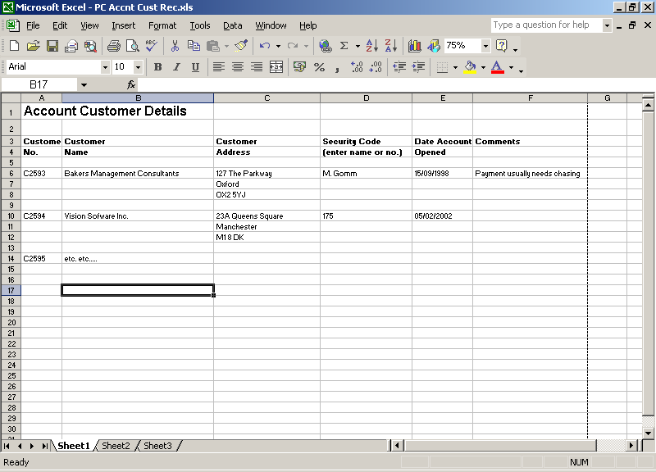

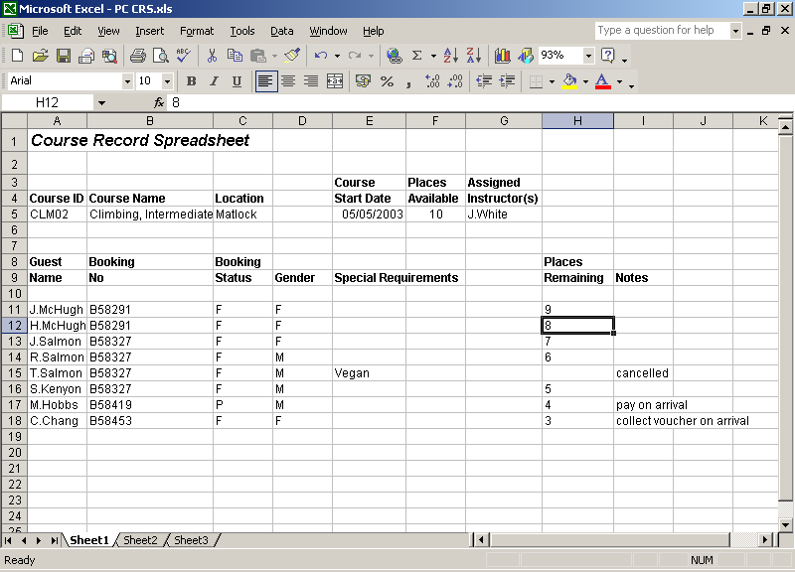

## Weekly Take Up Report

| Hostel Name | Week Comm. | No. of Courses | Total Places Available | Total Places Filled | % Take Up |
| --- | --- | --- | --- | --- | --- |
| Loch Tay | 07/04/23  14/04/23  21/04/23  28/04/23  05/05/23  12/05/23  19/05/23  26/05/23  02/06/23  09/06/23  16/06/23  23/06/23 | 5  5  5  5  7  7  7  7  6  7  8  8 | 36  36  36  36  60  60  60  60  56  60  72  72 | 35  31  36  24  58  41  47  60  54  55  70  68 | 97  86  100  67  97  68  78  100  96  92  97  94 |

## Scheduled Activity Report

| Course Code | Start Date | Places Available | Firm | Provisional | Total | % Take Up |
| --- | --- | --- | --- | --- | --- | --- |
| CLM02  CAN03  ORT01  VEN03  KAY01  ORT03 | 5/05/23  5/05/23  5/05/23  5/05/23  9/05/23  9/05/23 | 10  12  8  6  8  12 | 7  9  3  6  1  3 | 1  3  1  -  1  1 | 8  12  4  6  2  4 | 80  100  50  100  25  33 |

## Course Record Spreadsheet Report

| **Start Date** | **Length** | **Course ID** | **Max. No. of Places** | **Price (adult)** | **Price (child)** |
| --- | --- | --- | --- | --- | --- |
| 2 May 23 | 3 days | ABS01 | 8 | 150 | 100 |
|  | 3 days | KAY02 | 10 | 180 | 120 |
|  | 3 days | CAV03 | 12 | 210 | adults only |
| 5 May 23 | 5 days | CLM02 | 10 | 250 | 165 |
|  | 5 days | CAN03 | 12 | 290 | 190 |
|  | 5 days | ORT01 | 8 | 265 | 175 |
|  | 5 days | VEN03 | 6 | 315 | adults only |
| 9 May 23 | 3 days | KAY01 | 8 | 180 | 120 |
|  | 3 days | ORT03 | 12 | 175 | 115 |
| 12 May 23 | 5 days | CLM01 | 8 | 265 | 175 |
|  | 5 days | PON02 | 10 | 300 | 200 |
|  | 5 days | VEN03 | 6 | 315 | adults only |
| 16 May 23 | 3 days | CLM02 | 10 | 250 | 165 |
|  | 3 days | HNG01 | 8 | 250 | adults only |
| 19 May 23 | 5 days | CAN02 | 10 | 290 | 190 |
|  | 5 days | CLM03 | 12 | 250 | 165 |
|  | 5 days | HNG03 | 12 | 415 | adults only |

Child prices for ages 12-15 years.

Accommodation Only: £30 per person per night

## Course Codes

| **Course ID** | **Description** | **Level** |
| --- | --- | --- |
| ABS01 | Abseiling | Beginner |
| ABS02 | Abseiling | Intermediate |
| ABS03 | Abseiling | Advanced |
| CAN01 | Canoeing | Beginner |
| CAN02 | Canoeing | Intermediate |
| CAN03 | Canoeing | Advanced |
| CAV01 | Caving | Beginner |
| CAV02 | Caving | Intermediate |
| CAV03 | Caving | Advanced |
| CLM01 | Climbing | Beginner |
| CLM02 | Climbing | Intermediate |
| CLM03 | Climbing | Advanced |
| HNG01 | Hang Gliding | Beginner |
| HNG02 | Hang Gliding | Intermediate |
| HNG03 | Hang Gliding | Advanced |
| KAY01 | Kayaking | Beginner |
| KAY02 | Kayaking | Intermediate |
| KAY03 | Kayaking | Advanced |
| ORT01 | Orienteering | Beginner |
| ORT02 | Orienteering | Intermediate |
| ORT03 | Orienteering | Advanced |
| PON01 | Pony Trekking | Beginner |
| PON02 | Pony Trekking | Intermediate |
| PON03 | Pony Trekking | Advanced |
| VEN03 | Adventure Course | Advanced |

**Note: For Booking purposes, an individual course is identified by using its Course ID, Course Start Date and Location.**